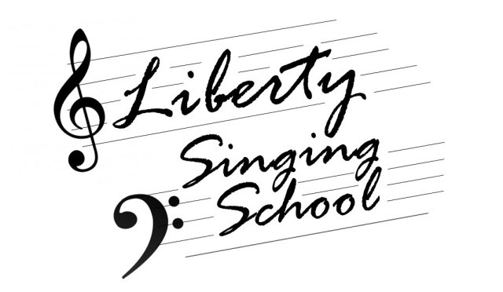

Liberty Singing School Registration Form December 27-30, 2018

Name Phone Email

# of Attendees

Please list the names and ages of all attendees:

If you would like to purchase a t-shirt, please list sizes and quantities:

T-Shirts are $10.00

Where are you traveling from?

Will you need a host family?

What day will you arrive?

How long will you stay?

Are you comfortable with staying in separate homes?

Please submit this form via email to rockymountpbc@gmail.com, or mail to
Rocky Mount Church, PO Box 288, Arab, AL 35016

